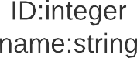

+O0ice ID:integer

room ID:integer

+number of seats:integer

Classroom

+EmpIoye

+EmpIoyee

Employee

+University name:string

+University code:integer

+University place:string

+University board:string

University



+De artment name:string

code:integer

Department

|  |
| --- |
| Professor |
| +Department nam  +subject:string  +saIary:integer |
| +fuII_professor()  +associate professor()  +assistant_professor() |